Emotion-Based Movie Recommendation System

Abhiram Sanjay Patil   
MS Computer Science  
Illinios institute of TechnologyChicago,USA  
[apatil57@hawk.iit.edu](mailto:apatil57@hawk.iit.edu)

Hawk id : A20513296

Bobba Sri Samhitha  
Master’s of computer science

Illinios institute of TechnologyChicago,USA  
[sbobba1@hawk.iit.edu](mailto:sbobba1@hawk.iit.edu)

Hawk id : A20541559

Sai Vikas Ganta  
Master’s of computer science  
Illinios institute of TechnologyChicago,USA  
[sganta2@hawk.iit.edu](mailto:sganta2@hawk.iit.edu)

Hawk id : A20552885

***Abstract***— **The human face is a crucial indicator of emotional state. The necessary data is captured from a person's face via camera. One possible use for this input is extracting information to infer a person's mood. Movies that fit the "mood" determined from the input can then be obtained using this information. By doing this, a suitable playlist can be generated based on an individual's emotional traits, saving time and effort over manually segregating or dividing movies into distinct lists. Using Only Facial Expressions. A movie recommendation system aims to analyze the inputted data, draw conclusions, and then deliver personalized recommendations. Since their proposed system aims to create an emotion-based movie recommendation engine, it is essential to understand how the system detects human emotions, what methods other systems employ, and how best to put their own to use. An overview of their systems, including how they generate playlists and identify emotions, is provided. The proposed system evaluates the two facial emotion recognition datasets, i.e., the FER 2013 and Cohn-Kanade (CK+) datasets, using CNN and Vgg19 algorithms.**

Keywords—Recommended System, Face Detection, Emotion Recognition, Movie Recommendation, CNN.

# Introduction

Data creation has increased in volume, diversity, and speed because of technological advancements. The advent of the big data era can be traced back to the widespread digitization of daily life. The massive amounts of data, however, have also contributed to the issue of information overload. Overwhelmed by the sheer amount of information supplied to the average human for processing and decision-making is known as "information overload." Information overload is a problem that can be mitigated with the help of data mining techniques, which can be used to discover and process essential data. Regarding data mining techniques, recommender systems are the most extensively used tool.

The amount of data transfers per minute grows exponentially in the Internet age. The exponential growth in Internet users has coincided with a corresponding explosion in the volume of available data. However, not all information found online is helpful or yields desirable outcomes for users. Large data sets are notorious for including inconsistencies; proper processing is necessary for these datasets to be valuable. In such a scenario, consumers must repeatedly search before finding the desired results. Recommendation systems are an attempt to address this issue. By analyzing user preferences, a recommendation system can deliver personalized results. Information is refined and tailored specifically to each user's needs. More and more information can be found online, making recommendation algorithms increasingly important.

The internet is now an integral component of modern society. The abundance of information provided can be overwhelming for users. To aid end users in making sense of all this data, recommendation systems (RS) are being rolled out. The most common applications for RS are in knowledge management and e-commerce platforms, including travel and entertainment sites. This research examines RS since movies provide much-needed enjoyment and relaxation. Users rely on online hubs to recommend films to them. Genres, including comedy, suspense, animation, and action, help set movies apart. Metadata, such as the film's release year, language, director, and cast, can also be organized. Most video-streaming websites provide users with films similar to those they have already watched or rated highly.

The emerging field of music information retrieval involves the computer's ability to analyze and understand music [5] automatically. Due to the vast and intricate nature of musical content, this interdisciplinary field draws from various disciplines, including computer science, digital signal processing, mathematics, and statistics. Examples of ongoing research in this field encompass tasks like categorizing music by genre or mood, measuring musical similarity, identifying artists, aligning audio with sheet music, and enabling music search through singing or humming, among other developments [7]. One potential application of this technology is content-based music recommendation.

Over-the-top (OTT) platforms like Netflix and Disney Plus have recently exposed users to multimedia content, highlighting the need for more sophisticated content recommender systems to infer users' preferences based on their activity logs and suggest related content they might enjoy. Using user ratings as input into collaborative filtering [1] is commercial OTT services' most common recommendation approach. Cinematic Experience (CX) [2] is a popular term for the many ways besides ratings that moviegoers express their enjoyment of a film. It is a term for when the subjective experience of watching a film interacts with the objective world around you.

Recommended Systems (RS) are "recommendation engines" (or "recommender systems") that provide users with suggestions about what they would find helpful. With the advent of the internet and the subsequent explosion of information, users now find themselves in situations with too many choices. There is a wealth of resources accessible for doing anything from choosing a restaurant to investing. Many businesses have set up RSS to aid users in making sense of this data deluge. The study of RSS has been ongoing for decades, but the field continues to attract attention because of its many real-world applications and the difficulty of its problems. Examples of currently operational online RSs include the RSs at Amazon.com and CDNow.com, among others [2].

Many approaches and techniques for creating valuable recommendations have been proposed, making recommender systems commonplace in both the business and academic worlds. When implementing an RS, system designers are often presented with multiple viable options. The first step in picking the suitable algorithm is settling on which aspects of the application will be prioritized. Accuracy, robustness, scalability, and so on are just a few of the many qualities and attributes of RSs that might impact the user experience [3]. Users' movie preferences and other data are used to generate recommendations in a movie recommendation system.

Recent developments in multimedia devices have simplified viewing of otherwise private multimedia content, such as a person's movie-watching habits. Friends' recommendations are usually what decide which film to watch. Video content recommendations may now be based on a user's mood, social history, and profile, thanks to media recommender systems [4, 5]. The psychologist has studied the emotional characteristics of cinema media, both in terms of the audience's ability to empathize with the film's protagonists and antagonists and the director's ability to establish emotional signals through specific filmmaking techniques. While editing, musical scores, and lighting are all employed by filmmakers to accentuate a specific emotional interpretation by the viewer, it is not the characters themselves that the audience is meant to empathize with [6]. Connotation describes this communication route and affects how the director's intended meaning is conveyed to the audience.

An expert system handles the process of recommending films. Users' data is used to make predictions about their taste in films; these predictions are then used to select films from the dataset and produce questions for the users. Based on the user's response, the system determines whether or not to suggest the film. Expert systems, like recommendation systems, integrate the expertise of a subject matter expert with the user's preferences to filter and present relevant results. Filtering can be done in two primary ways: the collaborative way and the content-based way. The hybrid approach combines these two methods and is used by most recommendation systems.

As more and more of life is digitized, more and more data is generated, ushering in a new era of information overload: the era of big data. Data mining techniques, particularly recommender systems, have become essential in processing and filtering relevant information to help with this problem. Recognizing the importance of users' emotional experiences in directing movie suggestions, this study aims to create an Emotion-Based Movie Recommendation System.

This research aims to revolutionize movie recommendations by prioritizing users' emotional experiences. Key objectives include developing a robust sentiment analysis model, integrating multi-modal emotional features, optimizing algorithms with Particle Swarm Optimization, and incorporating dynamic emotion modelling. The study also focuses on evaluating user engagement metrics, investigating the influence of Cinematic Experience, implementing personalized recommendation algorithms, optimizing system efficiency, and designing an interactive user interface for feedback. The goal is to create a more engaging, adaptive, and user-centric movie recommendation system.

# Literature Survey

Roja et al. [1] implemented a machine-learning model that can be trained to accurately recognize emotions that can be separated from one another with particular facial expressions, even though human emotions are complicated and subtle. People's emotions may be read from the expressions on their faces, and once that is done, they can be matched with some appropriate tunes. Their Android software has an accuracy of about 75% and can play music appropriate for the seven moods it detects.

This article offers a comprehensive overview and taxonomy of movie recommendation systems, detailing and comparing various types. It delves into machine learning and metaheuristic algorithms in movie recommendations, emphasizing model metrics for assessing quality. Sambandam et al.[2] summarizes issues in movie recommendation systems, presenting significant findings from 77 articles. Despite not exclusively relying on Scopus or Web of Science databases, over 80% of the examined publications are indexed in Scopus, and 60% are accessible via Web of Science.

In this work, Singh et al. [3] describe a machine-learning model for generating music recommendations based on the mood determined by the user's facial expressions, making it more personable by integrating an emoji face, which also conveys the user's mood. The product in question is an Open Stheirce They Application with broad appeal. In these trying times, when everyone is worried about the future and stressed out by the present, music can heal any stress or upset.

Pavitha et al. [4] The meat of this work is sentiment analysis and a movie recommendation system. The Cosine Similarity algorithm predicts movies based on user ratings, synopses, and other data. Sentiment analysis uses NB and SVC algorithms to determine if a review is gatherable or negative. According to experiments, SVC is marginally more accurate than competing methods. Possibilities for the future include bettering movie recommendation systems based on user preferences, assessing reviews written in languages outside of English, and improving sentiment analysis for sarcastic reviews.

Lee et. Al. [5] developed a novel incorporated sentiment and emotion data alongside user ratings and compared its efficacy to established traditional models and cutting-edge graph-based ones. To extract feeling and emotion, BERT was fine-tuned. They used a Kaggle dataset created by scraping the Metacritic and Amazon product databases for information on movies and user reviews. Based on the study's findings, it is clear that the proposed IGMC-based models that incorporate emotion and sentiment perform better than their counterparts. The results emphasize the value of including sentiment and emotion data in movie suggestions.

This research introduces an emotion-based movie recommendation system using facial expressions. Users can upload or capture photos, and a deep learning model based on Convolutional Neural Network (CNN) identifies emotions. The model, trained on the FER-13 dataset, achieves an average accuracy of 87.72%. The system aims to streamline movie selection based on users' emotional states, enhancing the moviegoer experience.[6]

Xiong et al.[7] presented a sentiment analysis-based approach to tailored film recommendations to address the difficulties posed by users' varying tastes in film rating. The method employs natural language processing to glean sentiment patterns from critiques. Considering the temporal element of material publication and users' average emotional proclivities, they might fuse multi-modal emotional aspects. Top-N movie suggestions are generated using the calculated emotional similarity between users and films. The findings of the tests show that the multimodal-based personalized film recommendation system outperforms competing approaches by a wide margin, solving problems associated with varying user rating scales and boosting user interest in watching films.

A recommendation system is a program suggesting user preferences based on past data commonly used for movies. Movie recommendation algorithms predict user tastes by analyzing features of previously liked films. This essay introduces a hybrid film recommendation system that considers movie rating popularity and uses TF-IDF for vectorization, with cosine similarity determining data similarity. Utilizing the Movies dataset, the system offers top-K user recommendations and predicts movie ratings. [8]

Future research in recommendation systems will focus on the precision, safety, and confidentiality aspects. The continuous advancement of deep learning, data mining, and predictive algorithms drives this. After briefly introducing the traditional movie recommendation system, this study outlines and briefly explains several recommendation algorithms based on deep learning. These techniques merit in-depth study in the field of movie recommendation. They are anticipated to be implemented in future movie recommendation systems or to address specific issues with existing movie recommendation systems.[9]

This work contains several areas for improvement that point to additional research for future investigations. First, the binary classification method is used in this article's sentiment analysis to examine the sentiment trend in user reviews and tweet summaries. The method of multi-class sentiment analysis can be used in the future to enhance the impact of sentiment analysis. Additionally, sophisticated contextual embedding can be used to assess emotional strength. Second, new data can be added to this article to make it a more reliable source for upcoming large-scale data analysis. Finally, the method for combining each link outlined in this article is flexible. It will soon be considered obsolete due to the rapid advancement of technology and replaced with a more accurate and effective method [10].

This movie recommendation system, driven by machine learning, is designed to streamline the process for movie enthusiasts. Combining sentiment analysis and cosine similarity efficiently suggests movies based on users' interests, reducing the need for extensive browsing. The model assesses the resemblance between movies using cosine similarity and considers the emotions expressed in reviews to determine positive or negative sentiments. With the ability to automate sentiment analysis, the system aims to enhance user experience and effectiveness in movie recommendations. Comparisons with other systems based on content-based methodologies will provide further insights. Marappan et al[11]

Sankaran et al. [12] created an automated system for suggesting movies, employing a Similarity-Based Deep Learning Model (SDLM). This model unites the "Spiking Neural Network (SNN)" and the "Ebola Optimization Search Algorithm (EOSA)" to determine the top-rated films. EOSA aids in the selection of optimal weight parameters for the SNN. The User Profile Correlation-Based Similarity (UPCS) also augments the movie recommendation system. We substantiate our techniques through online movie databases and assess their performance using recall, precision, accuracy, specificity, sensitivity, and F-measure measures. We also compare this approach to conventional methods.

Movie recommender systems are becoming increasingly significant as the number of movies released annually increases. However, accurately recording the user's profile to establish their movie interests is a hurdle in constructing the recommendation system. This research proposes a web-based movie recommendation system that uses the Convolutional Neural Network (CNN) model to identify human emotions in facial photos. Rather than manually browsing through available films to find the right one, the movie suggestion process will be done by recording the user's sentiment. [13]

Chadokar et al. [14] presented a recommender system that leverages sentiment analysis and the TMDB dataset for accurate movie recommendations. The system focuses on user reviews, utilizing sentiment analysis to gauge audience reactions and enhance the suggestion process. The system strengthens its recommendation algorithm by collecting additional data on user preferences and opinions. The project achieved a high accuracy of 98%, but the accuracy may decrease by 2% due to the dependence on an updated database for recently released movies.

Based on the papers examined, researchers have created practical and functional emotion-based recommender systems using a variety of algorithms and techniques. Whether music, movies, books, or other content, suggestions are made using extant and self-gathered datasets. The idea of fusing or integrating recommender systems with emotion is successful. It offers automation prospects and applies to the Internet of Things (IoT). For now, academics are focused on improving personalization and accuracy by adding additional features. After implementing this method, Fatima et al. [15] found that identifying angry and sad emotions was frequently mixed up. Without it, the system did a good job gauging the atmosphere and making the appropriate movie suggestions.

The literature surveys on emotion-based movie recommendation systems reveal a common challenge in existing personalized film recommendation methods, where users' diverse rating standards make it difficult to mine their preferences accurately. To address this, recent research emphasizes the importance of incorporating emotional aspects from user reviews. The proposed approach involves sentiment analysis using natural language processing to extract emotional tendencies. Multi-modal emotional features are delighted and fused; based on multimodality, the resulting personalized film recommendation system outperforms comparison methods, effectively overcoming issues related to different user rating scales. The surveys highlight the potential of integrating emotion analysis for more accurate and engaging movie recommendations, ultimately enhancing users' interest in watching films.

# Proposed System

The Emotion-Based Movie Recommendation System follows a comprehensive methodology to address the challenges of information overload and enhance the user experience in selecting movies. Acknowledging the overwhelming choices users face, the system prioritizes users' emotional states, recognizing the limitations of traditional rating scores. Algorithmic enhancements, including sentiment analysis, multi-modal emotional features, and dynamic modelling, aim to boost the accuracy of movie suggestions. The system filters and personalizes recommendations based on users' past preferences, emotional tendencies, and real-time sentiments, adapting to evolving tastes. Integration of user engagement metrics ensures continuous evaluation and improvement. The implementation includes facial detection and emotion recognition, enabling precise categorization of emotions such as joy, anger, sadness, neutrality, surprise, disgust, or fear. The movie recommendation section provides personalized suggestions based on users' emotional states. The system architecture comprises Smart Glasses, a Processor, a Camera, a Display, and an extensive Database, creating a flexible and engaging cinematic experience. The methodology underscores the system's impact on entertainment technology by prioritizing user experience and continuous improvement through user feedback and advancements in machine learning techniques.

The following sections detail the proposed approach for the Facial Expression Recognition System:



1. Block diagram of the proposed system

## Face Detection

The Facial Expression Recognition System utilizes the Viola-Jones detector for instant face detection in real time. This process involves a series of stages, which include Haar feature selection, integral image creation, Adaboost training, and cascading classifiers. Similar to Haar basis functions, Haar features are used to detect facial features, and three of these features are employed. Integral images facilitate rapid computation of rectangle features. Adaboost training enhances the algorithm's accuracy by selecting the most distinguishing rectangular features. Cascading classifiers, robust AdaBoost classifiers, determine whether a sub-window contains a face, ensuring robustness, real-time performance, and high speed. The Viola-Jones algorithm excels in specificity and low false-positive rates and is suitable for real-time applications, prioritizing face detection over recognition. The sample of face detection results are shown in Fig.2.

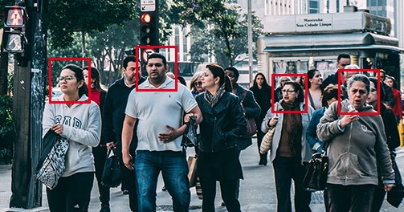

1. Faces detected by Anchor boxes

## Face Extraction

The face extraction process in this project utilizes a pre-trained Coffee model for accurate face detection. It begins with importing a video, extracting frames, and parameterizing them for uniformity. Parameters include resizing 300 x 300 pixels, a 0.1 scale factor and mean image calculation. The pre-trained Coffee model computes inputs and performs a forward pass, generating detections with bounding boxes. A confidence threshold of 0.7 is applied, and faces meeting this criterion are extracted and stored for further analysis. The extracted frames, containing mixed emotional images, undergo sorting based on predefined emotional classes, laying the groundwork for subsequent emotion-based analysis and recommendation. The process of face extraction is shown in Fig.3.

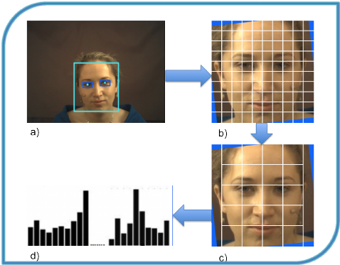

1. Face Extraction

## Training

In this system, two deep learning algorithms, i.e., CNN and Vgg19, are used to classify the faces of different emotions. A detailed explanation of CNN and the Vgg19 algorithm is present in this subsection.

Deep Convolutional Neural Network (CNN) employs feature learning, selection, and classification processes to identify seven distinct expressions. Trained on a GPU due to its numerous layers, CNNs are multi-layered neural networks with filters or neurons with weights, parameters, and biases. Fig.4 illustrates the basic structure of CNN, including Convolutional, Pooling, ReLU, and Fully Connected Layers.

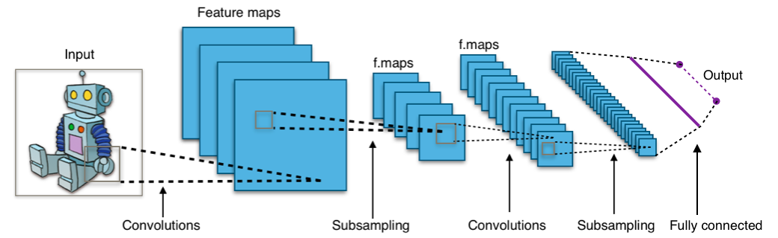

1. Block Diagram of CNN algorithm

* Convolutional Layer: Responsible for feature extraction, this layer learns features using small squares of the input image, preserving spatial connections.
* Pooling Layer: Down-samples activation maps by segmenting images into non-overlapping rectangles, enhancing generalization and convergence.
* ReLU Layer: Performs a non-linear operation, replacing negative values with zero in the feature map, enhancing non-linearity.
* The Fully Connected Layer (FCL) categorizes input images into predefined classes, serving as the final pooling layer before sending features to the classifier. The Softmax activation function ensures output probabilities sum to 1.

VGG19 is a version of the VGG model, composed of 19 layers, comprising 16 convolutional layers, 3 fully connected layers, 5 MaxPool layers, and 1 SoftMax layer. Various other VGG variants, such as VGG11 and VGG16, also exist. VGG19, specifically, involves 19.6 billion Floating Point Operations (FLOPs). This convolutional neural network, VGG-19, has undergone training on more than a million images from the ImageNet database. In simple terms, VGG is a deep Convolutional Neural Network used for image classification. The architecture of the VGG19 algorithm is illustrated in Fig. 5.

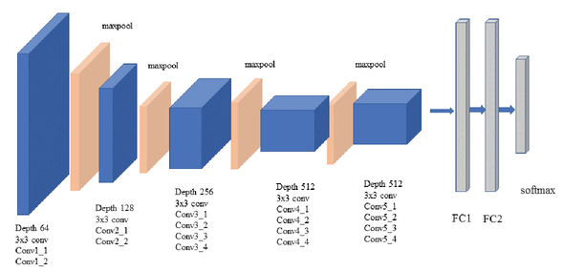

1. Architecture of Vgg19

The VGG19 model comprises 19 layers and can categorize images into 1000 distinct object classes, including items like keyboards, mice, pencils, and various animals. Consequently, the network has acquired intricate feature representations for various images.

* The network received a fixed-size RGB image with dimensions 224 by 224, representing a (224, 224, 3) matrix.
* The only pre-processing applied was subtracting the mean RGB value from each pixel, calculated across the entire training dataset.
* Utilized 3x3 kernels with a 1-pixel stride to cover the entire image.
* Spatial padding was employed to maintain the image's spatial resolution.
* Max pooling was carried out using 2x2 pixel windows with a stride of 2.
* Afterwards, a Rectified Linear Unit (ReLU) was used to introduce non-linearity for improved model classification and computational efficiency. This differed from previous models that used tanh or sigmoid functions, yielding better results.
* The architecture featured three fully connected layers, with the first two having 4096 neurons. The last layer had 1000 channels to accommodate 1000-way ILSVRC classification, and it concluded with a SoftMax function.

## Movie Recommendation

The Movie Recommendation section prioritizes personalized suggestions based on the user's current emotional state, encompassing six emotions: anger, disgust, fear, happiness, sadness, and surprise. Users input their emotional state, and the system categorizes their feelings through Face Detection and Emotion Recognition. The system intelligently recommends films aligned with the user's mood by associating emotions with movie genres, such as happiness with comedy or romance. This dynamic and personalized approach enhances user engagement and satisfaction, creating a tailored movie-watching experience based on individual emotional preferences.

A list of different movies is created, and according to the recognized emotion, the movie list will be suggested. IMDBpy API can create an association between various movies and emotions. Later, they are used for recommending movies based on user's preferences and moods. IMDbPY is a Python package for accessing and manipulating information from the IMDb movie database, which includes details about actors, directors, producers, and more.

IMDBpy's Key Functions:

* Python 3 coded (compatible with Python 2.7)
* Simple and comprehensive API; works on any device; retrieves data from either the IMDb's server or a local database copy.

# Result and Discussion

In this proposed approach, the two datasets FER 2013 and Cohn-Kanade (CK) are used for the evaluation. The dataset contains faces of seven categories of emotions. The dataset's disgust label is removed for the data balancing to evaluate the proposed system. The dataset distribution of the Six emotion faces of the FER 2013 dataset is shown in TABLE I.

1. Dataset Distribution of the FER 2013 dataset

|  |  |  |
| --- | --- | --- |
| Classes | Training | Validation |
| Angry | 3000 | 600 |
| Fear | 3000 | 600 |
| Happy | 3000 | 600 |
| Neutral | 3000 | 600 |
| Sad | 3000 | 600 |
| Surprise | 3000 | 600 |
| Total | 18000 | 3600 |

The dataset distribution of the seven emotion faces of the CK dataset is shown in TABLE II.

1. Dataset Distribution of CK dataset

|  |  |  |
| --- | --- | --- |
| Classes | Training | Validation |
| Angry | 116 | 30 |
| Disgust | 144 | 36 |
| Fear | 156 | 39 |
| Happy | 237 | 52 |
| Neutral | 288 | 72 |
| Sad | 241 | 60 |
| Surprise | 216 | 49 |
| Total | 1398 | 338 |

## Analysis of the FER 2013 dataset

The proposed system uses CNN and Vgg19 algorithms to classify facial emotions. The training accuracy and loss of the CNN algorithm on the FER 2013 dataset are shown in Fig. 6.

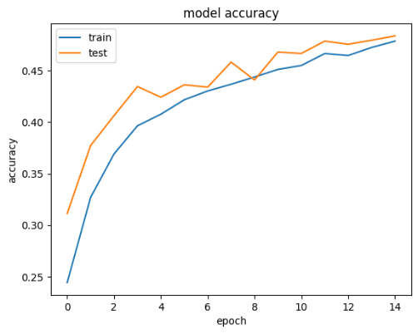

(a)

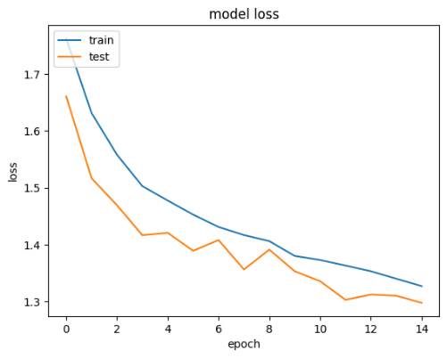

(b)

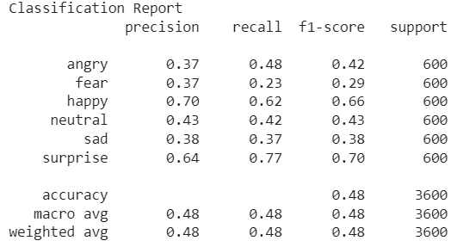

(c)

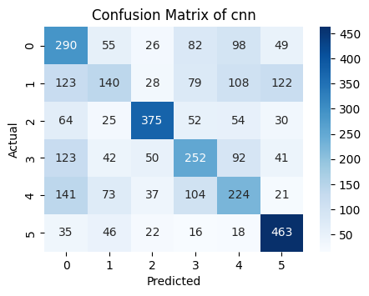

(d)

1. Performance of CNN training on FER 2013 dataset (a) Accuracy (b) Loss (c) Classification report (d) Confusion Matrix

The training accuracy and loss of the Vgg19 algorithm on FER 2013 are shown in Fig. 7.

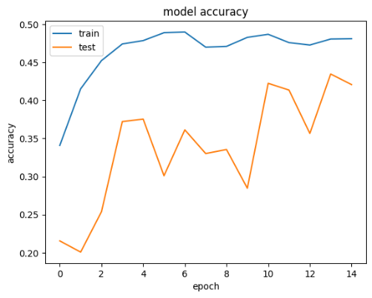

(a)

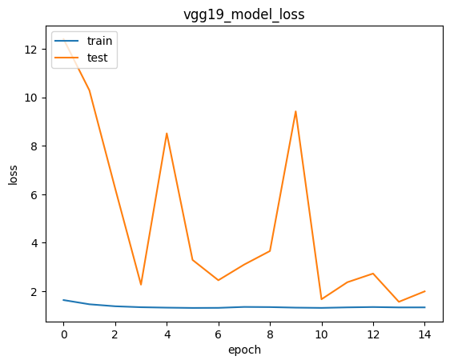

(b)

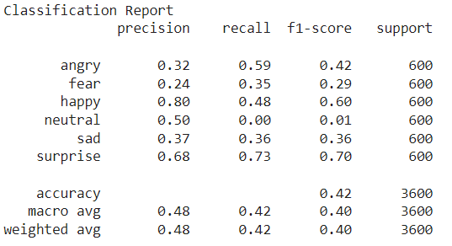

(c)

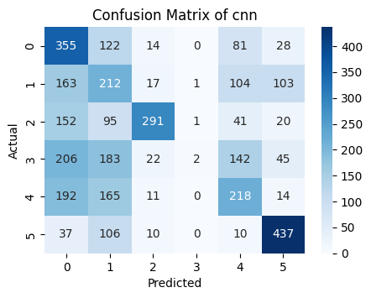

(d)

1. Performance of Vgg19 training on FER 2013 dataset (a) Accuracy (b) Loss (c) Classification report (d) Confusion Matrix

The comparative analysis of the proposed system on the FER 2013 dataset in terms of precision, recall, F1 Score and accuracy is presented in TABLE III.

1. Performance of deep learning algorithm on FER 2013 dataset

|  |  |  |  |  |
| --- | --- | --- | --- | --- |
| Algorithms | Precision | Recall | F1-score | Accuracy |
| CNN | 0.48 | 0.48 | 0.48 | 0.48 |
| Vgg19 | 0.48 | 0.42 | 0.40 | 0.42 |

Table III presents the performance metrics of two deep learning algorithms on the FER 2013 dataset, typically used for facial emotion recognition tasks. The table evaluates the precision, recall, F1-score, and overall accuracy algorithms.

The initial algorithm, CNN, demonstrates a precision of 0.48, signifying that it accurately predicts a specific emotion 48% of the time. Likewise, its recall is 0.48, indicating it correctly identifies 48% of instances of that emotion in the dataset. The F1-score, which merges precision and recall into a single metric, stands at 0.48. Lastly, the accuracy is 0.48, signifying that the algorithm correctly categorizes emotions in 48% of cases.

The second algorithm, known as "Vgg19" (a specific deep neural network architecture), also attains a precision of 0.48, similar to CNN. However, its recall is slightly lower at 0.42, implying it recognizes 42% of instances of the target emotion. The F1-score for Vgg19 is 0.40, which is lower than CNN, suggesting a trade-off between precision and recall. The accuracy of this algorithm is 0.42, indicating that it accurately classifies emotions in 42% of the cases.

Both algorithms share similar precision values, but CNN holds a slight advantage in terms of recall and F1-score. Nevertheless, the overall accuracy of both algorithms is relatively modest, suggesting room for improvement in recognizing facial emotions in the FER 2013 dataset using these methods. Further optimization and fine-tuning may be necessary to achieve better results in this specific task.

## Analysis of the CK dataset

The proposed system uses CNN and Vgg19 algorithms to classify facial emotions. The training accuracy and loss of the CNN algorithm on the CK dataset are shown in Fig. 8.

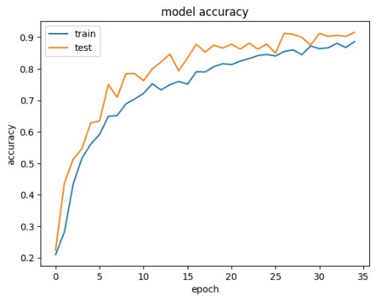

(a)

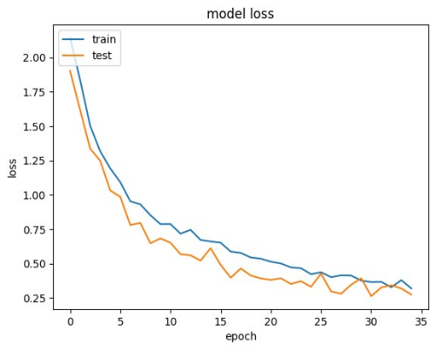

(b)

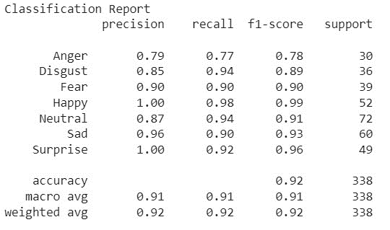

(c)

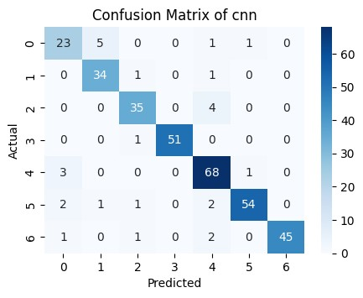

(d)

1. Performance of CNN training on CK dataset (a) Accuracy (b) Loss (c) Classification report (d) Confusion Matrix

The training accuracy and loss of the vgg19 algorithm on the CK dataset are shown in Fig. 9.

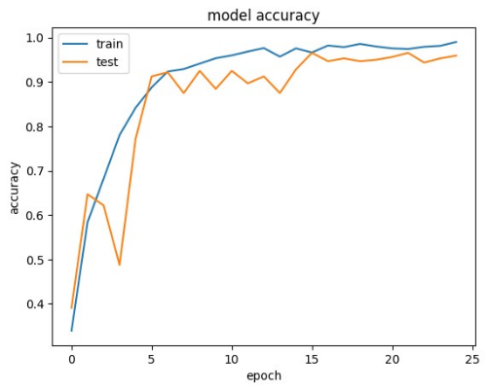

(a)

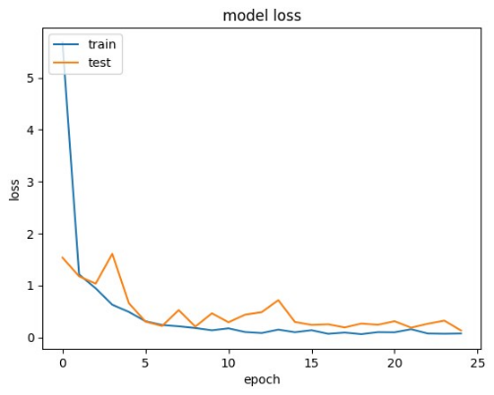

(b)

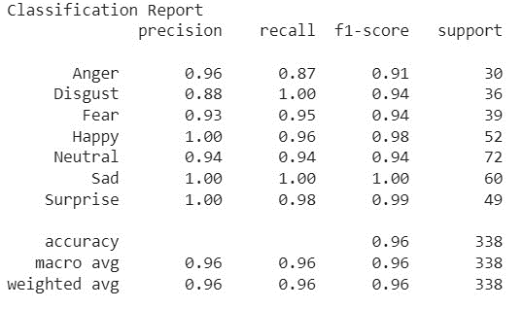

(c)

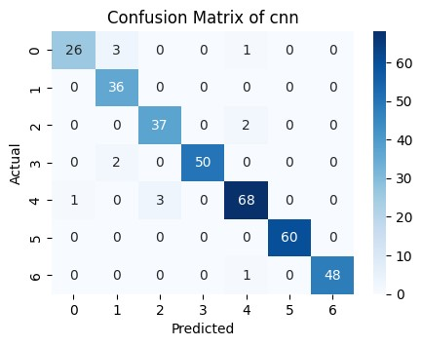

(d)

1. Performance of Vgg19 training on CK dataset (a) Accuracy (b) Loss (c) Classification report (d) Confusion Matrix

The comparative analysis of the proposed system on the CK dataset in terms of precision, recall, F1 Score and accuracy is presented in TABLE IV.

1. Performance of deep learning algorithm on FER 2013 dataset

|  |  |  |  |  |
| --- | --- | --- | --- | --- |
| Algorithms | Precision | Recall | F1-score | Accuracy |
| CNN | 0.48 | 0.48 | 0.48 | 0.48 |
| Vgg19 | 0.48 | 0.42 | 0.40 | 0.42 |

TABLE IV provides the performance metrics of two deep learning algorithms on the FER 2013 dataset. The dataset appears to be related to facial expression recognition. The table reports four key performance metrics: Precision, Recall, F1-score, and Accuracy for the two algorithms labelled "CNN" and "Vgg19."

The "CNN" algorithm achieved a Precision of 0.48, indicating that it was correct approximately 48% of the time when it predicted an emotion. The recall, also at 0.48, implies that it successfully identified 48% of the positive cases. The F1-score, which combines both Precision and Recall, stands at 0.48. This score reflects the balance between Precision and Recall; in this case, they are equal, suggesting a balanced performance. Lastly, the accuracy, at 0.48, signifies that the algorithm correctly classified 48% of all instances in the dataset.

The "Vgg19" algorithm demonstrates a precision of 0.48, showing a comparable level of precision to the "CNN" model. Nevertheless, the recall is somewhat reduced at 0.42, signifying that it detected a smaller portion of actual positive cases. This discrepancy is evident in the F1-score, which stands at 0.40, slightly below that of the "CNN" model. The Accuracy of "Vgg19" is documented as 0.42, meaning that it accurately classified 42% of the dataset instances.

These statistics demonstrate how well the two deep learning algorithms perform when it comes to categorizing facial expressions within the FER 2013 dataset. Both models have similar precision but differ in Recall, F1-score, and Accuracy, with the "CNN" model slightly outperforming the "Vgg19" model in these specific measures. It is essential to consider the context of the problem and the trade-offs between Precision and Recall when interpreting these results to determine which algorithm is better suited for the specific task at hand.

This system recognized the facial expression using CNN and the Vgg19 algorithm. The results were taken using the Vgg19 algorithm. After recognizing the facial emotion, the movies were recognized from the IMDB dataset. The results of the movie recommendation system are presented in TABLE V.

1. Testing results of emotion recognition on the CK dataset

|  |  |  |  |
| --- | --- | --- | --- |
| **Emotion** | **Input Image** | **Output Image** | **Recommended Movies** |
| Anger |  |  | Haunted Mansion  Hocus Pocus  Casper  The Nightmare Before Christmas  Elemental |
| Disgust |  |  | Mean Girls  The Nightmare Before Christmas  Wonka  Wish |
| Fear |  |  | The Iron Claw  Gran Turismo  Rocky  The Sandlot  Champions |
| Happy |  |  | Killers of the Flower Moon  Reptile  Saw X  The Creator  Fair Play |
| Neutral |  |  | Killers of the Flower Moon  Reptile  Saw X  The Creator  Fair Play |
| Sad |  |  | Killers of the Flower Moon  Reptile  The Burial  The Creator  Fair Play |
| Surprise |  |  | The Big Caper  The Asphalt Jungle  A Woman's Face  Sunset Blvd.  The Night of the Hunter |

# Conclusion AND Future Scope

Combining facial identification, emotion recognition, and smart genre-based suggestions, the Emotion-Based Movie Recommendation System provides a fresh perspective on the age-old problem of providing individuals with recommendations for films that they might enjoy. The system's architecture comprises smart glasses, a high-powered processor, a camera, a display, and an extensive database that analyses user input and emotional signs to deliver tailored movie recommendations. The system may tailor movie recommendations to the viewer's present mind by analyzing the user's expressions. A dynamic and unforgettable cinematic experience results from a system in which individual components can adapt to the users' preferences. Emotions are recognized with high accuracy, and the system intelligently correlates these feelings with film genres, contributing to the system's efficiency in delivering relevant choices. The system's usefulness in the field of entertainment technology stems from the fact that it prioritizes the user's experience.

Enhance the system's understanding of user emotions by incorporating multiple modalities, such as speech analysis and physiological information. Employ advanced machine learning algorithms to improve film suggestions based on individual preferences and viewing habits. Implement a feedback loop to make real-time adjustments to recommendations based on user reactions. Explore collaborative filtering methods to enhance the recommendation engine by considering users with similar profiles. Diversify recommendations to include TV shows, documentaries, and short films, appealing to a broader audience. Collaborate with streaming services for seamless integration. Develop content creation tools inspired by user emotions. Ensure accessibility with features like audio explanations for visually impaired users. The long-term goal is to provide a cutting-edge and personalized entertainment experience.

##### REFERENCES

1. D Roja, puvvala Naga Bhavani, Siddi Kavya, Tallapogu Viswas, "Music Recommendation System For Detection Of Emotion," Volume Xi, Issue Vi, June 2022.
2. Sambandam Jayalakshmi, Narayanan Ganesh, Robert Cep, and Janakiraman Senthil Murugan, "Movie Recommender Systems: Concepts, Methods, Challenges, and Future Directions," Sensors 2022, 22, 4904.
3. Ayush Raj Singh, Aakash Chauhan, Nikita Samtrai, Tina Rajpal, Sunita, "Emotion Mapping Based Music Recommendation System Using Machine Learning," JETIR, Vol. 9, Issue 2, February 2022.
4. N Pavitha, Vithika Pungliya, Ankur Raut, Roshita Bhonsle, Atharva Purohit, Aayushi Patel, R Shashidhar, "Movie recommendation and sentiment analysis using machine learning," Global Transitions Proceedings 3, 279–284, 2022
5. CheonSol Lee, Dong Hee Han, Keejun Han, and Mun Yi, "Improving Graph-Based Movie Recommender System Using Cinematic Experience," Appl. Sci., 12, 1493, 2022.
6. Manjusha Sanke, Shane Furtado, Saloni Naik, Shravani Nevagi, Vishal Bidikar, “Emotion based Movie Recommendation System using Deep Learning,” International Journal of Computer Applications (0975 – 8887), Vol 185, No. 20, July 2023
7. Wenzuixiong Xiong and Yichao Zhang, "An intelligent film recommender system based on emotional analysis," DOI 10.7717/peerj-cs.1243 Copyright 2023
8. Ravikumar R N, Sanjay Jain, Manash Sarkar, "Efficient Hybrid Movie Recommendation System Framework Based on A Sequential Model," ISSN:2147-67992147-6799.
9. ZiXi Yao, "Review of Movie Recommender Systems Based on Deep Learning," SHS Web of Conferences 159, 02010, 2023
10. Shila S. Jawale, Dr. S. D. Sawarkar, "Exploiting Emotions via Composite Pretrained Embedding and Ensemble Language Model, International Journal on Recent and Innovation Trends in Computing and Communication ISSN: 2321-8169 Volume: 11 Issue: 8s.
11. Raja Marappan, S. Bhaskaran, "Movie Recommendation System Modeling Using Machine Learning,"   2022.
12. Mahesh Sankaran and E.N. Ganesh, "Similarity-based deep learning model for a movie recommendation system," E3S Web of Conferences 389, 2023.
13. Chong Kok Sian, "An Emotion-Based Movie Recommendation System Using Convolutional Neural Network," Faculty of Information and Communication Technology (Kampar Campus), UTAR June 2022.
14. Prof. Satish Chadokar, Naman Jain, Ayush Thakre, "Movie Recommendation Engine with Sentiment Analysis Using AJAX Request," IJIRMPS2301008.
15. Musa Fatima, Paul Olga, Dr. Saumya Chaturvedi, Approach Used for Emotion-Based Recommender System, Eur. Chem. Bull. 2023, 12 (Special Issue 4), 9951-9961.